**Assignment No. 1**

Q) Create a private repository on GitHub. Inside that repository, add an index.html file.

Then, create a Jenkins job to deploy the index.html file from the remote repository to the HTTP server.

***Answer >>>>***

Step 1) To create a job click on new item then enter name and select freestyle project and click ok

Step 2) Integrate git with Jenkins

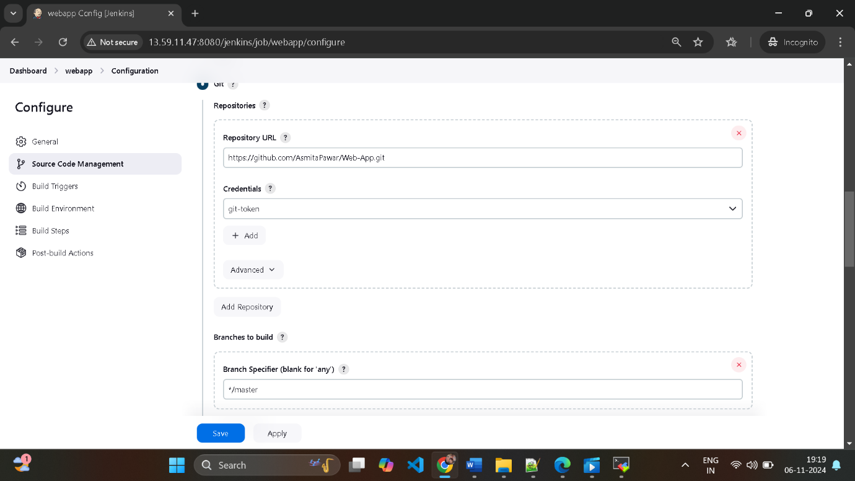-

Step 3) Select the option

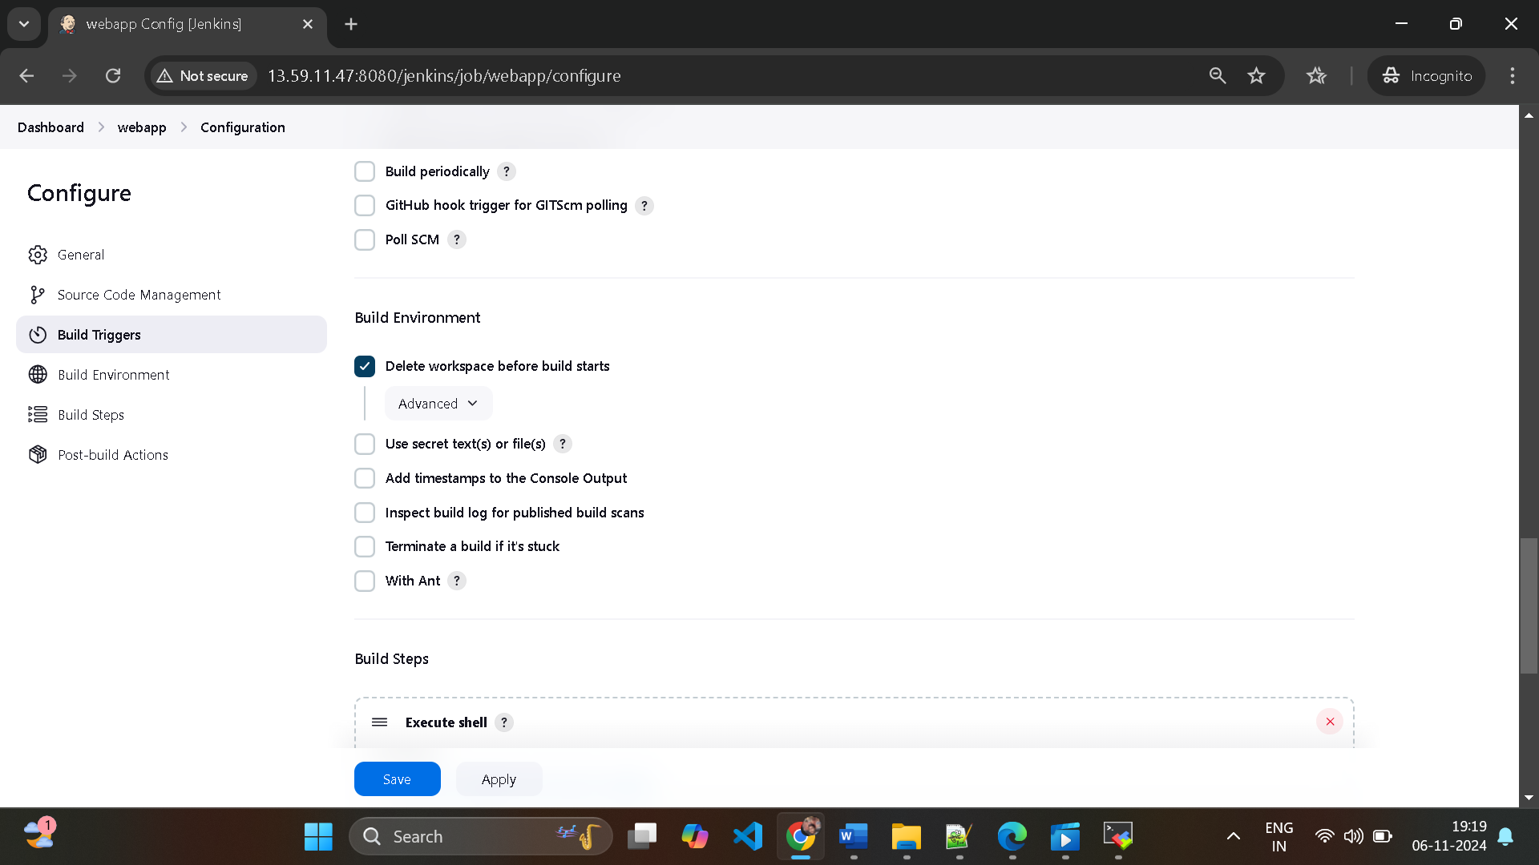

Step 4) In build steps select execute shell

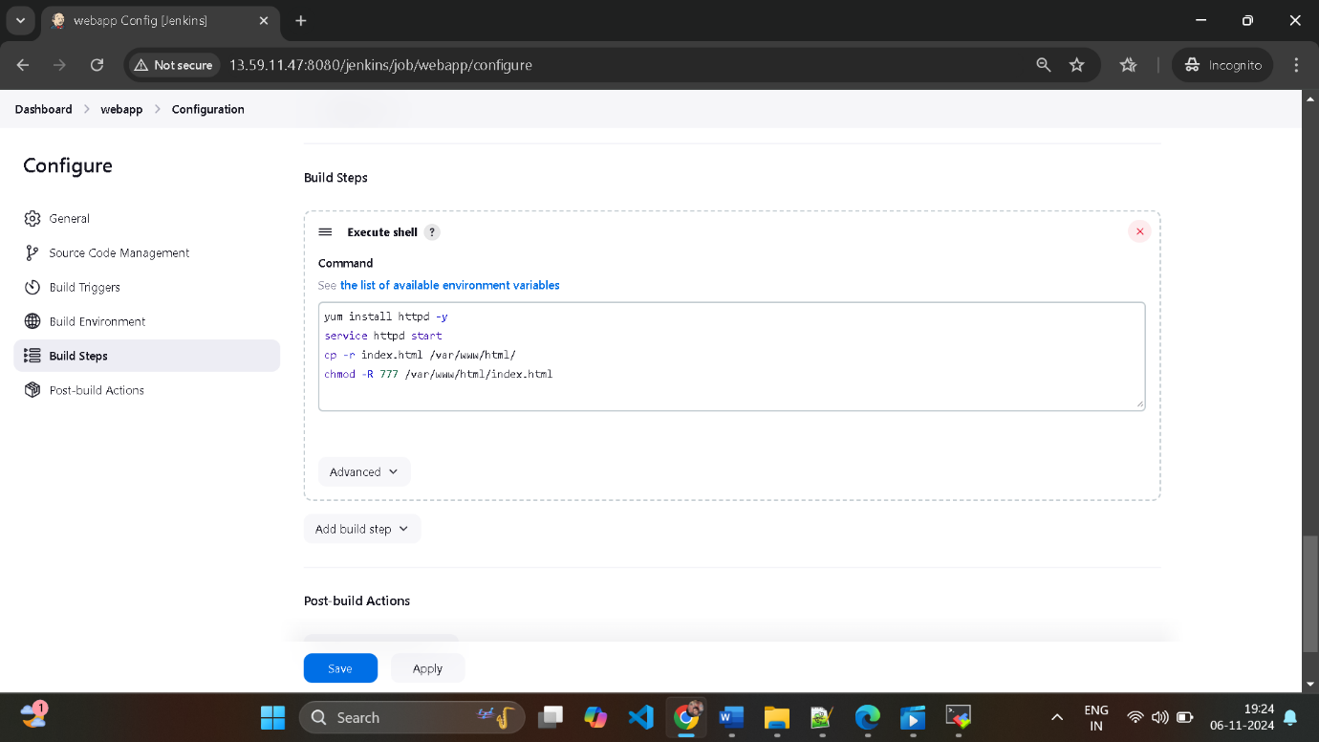

And then apply and save

Step 4) click on build now and check build history and check console output

Started by user [asmita](http://13.59.11.47:8080/jenkins/user/asmita_64)

Running as SYSTEM

Building in workspace /root/.jenkins/workspace/webapp

[WS-CLEANUP] Deleting project workspace...

[WS-CLEANUP] Deferred wipeout is used...

[WS-CLEANUP] Done

The recommended git tool is: NONE

using credential git-token

Cloning the remote Git repository

Cloning repository <https://github.com/AsmitaPawar/Web-App.git>

> git init /root/.jenkins/workspace/webapp # timeout=10

Fetching upstream changes from <https://github.com/AsmitaPawar/Web-App.git>

> git --version # timeout=10

> git --version # 'git version 2.40.1'

using GIT_ASKPASS to set credentials git-token

> git fetch --tags --force --progress -- <https://github.com/AsmitaPawar/Web-App.git> +refs/heads/*:refs/remotes/origin/* # timeout=10

> git config remote.origin.url <https://github.com/AsmitaPawar/Web-App.git> # timeout=10

> git config --add remote.origin.fetch +refs/heads/*:refs/remotes/origin/* # timeout=10

Avoid second fetch

> git rev-parse refs/remotes/origin/master^{commit} # timeout=10

Checking out Revision 67b9d11ce9fd7fdcfce10c3461d908eb82ca44e3 (refs/remotes/origin/master)

> git config core.sparsecheckout # timeout=10

> git checkout -f 67b9d11ce9fd7fdcfce10c3461d908eb82ca44e3 # timeout=10

Commit message: "Add index.html file"

> git rev-list --no-walk 67b9d11ce9fd7fdcfce10c3461d908eb82ca44e3 # timeout=10

[webapp] $ /bin/sh -xe /mnt/servers/apache-tomcat-9.0.96/temp/jenkins11401802443319875426.sh

+ yum install httpd -y

Loaded plugins: extras_suggestions, langpacks, priorities, update-motd

Package httpd-2.4.62-1.amzn2.0.2.x86_64 already installed and latest version

Nothing to do

+ service httpd start

Redirecting to /bin/systemctl start httpd.service

+ cp -r index.html /var/www/html/

+ chmod -R 777 /var/www/html/index.html

Finished: SUCCESS